**Digital Logic Design**

**Lab # 04**

***Student Name: Muhammad Ahmed Baig Reg# 20i-1884***

***Lab Section:B***

**LabTitle:**

1. XOR Gate from Universal (NOR) Gates
2. Use of logic probe for debugging a circuit

**Objectives:**

To become familiar that the universal gate (NOR) can be used to design any other gate and in fact any combinational circuit

**Equipment Required:**

* DEV-2765E Trainer Board
* 7402 quad 2-input NOR gate IC

**Diagram:**

Boolean Representation of XOR Gate

A + B = AB + AB

**Gate Diagram of the above Boolean function:** 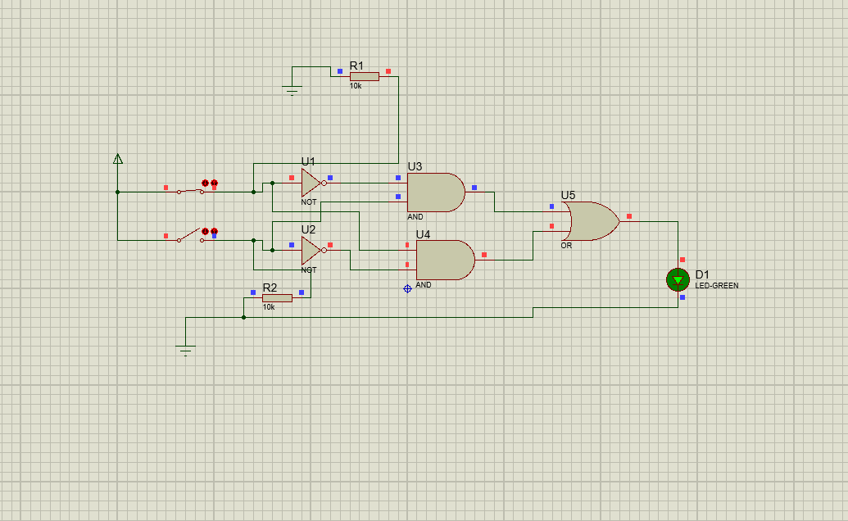

**Diagram of XOR gate constructed from NOR Gates**

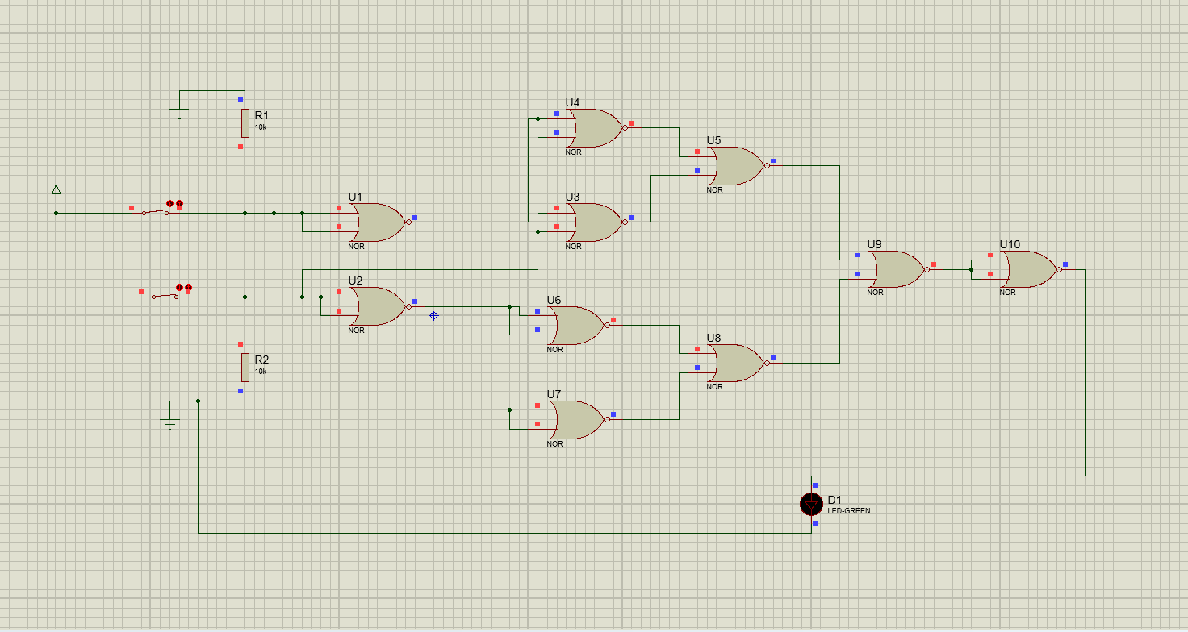

***Truth Table***

|  |  |  |
| --- | --- | --- |
| In | put | Output |
| A | B | A + B |
| 0 | 0 | 0 |
| 0 | 1 | 1 |
| 1 | 0 | 1 |
| 1 | 1 | 0 |

***Procedure***

1. Connect the trainer board with the power supply 2. Mount the corresponding 74LS00 IC on the board.

1. Connect pin 14 to +5 V and pin 7 to GND.
2. Wire the circuit according to the diagram by consulting the corresponding gate ICs data sheet.
3. Apply all the combinations of inputs and observe the output on the LED to verify the truth tables of the gates.